Computer Language Coding Concepts

Basic System Command Calls
Even though a call to a system command can get a complex notation when fully drawn out, system command calls also have a basic notation. System command calls are so fundamental, that they get the most basic notation that still fits within the language.

There are system commands that apply to object references and to the object itself.

System commands, that apply to an object reference are displayed with a parent around the targeted reference:

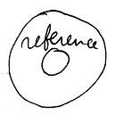

System commands, that apply to the object itself are displayed without a parent around the targeted object.

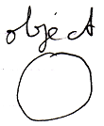

Here follow the basic notations for all the system commands.

The line type indicates the aspect.
A word like Get, Set or Use indicates direction.
The access mark indicates the object of which the system command is called.

Object Get | Object Set
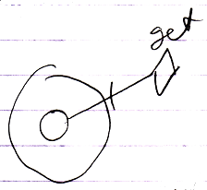 | 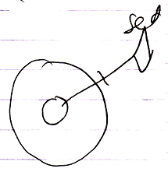
Use As Class | Class Set
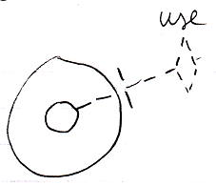 | 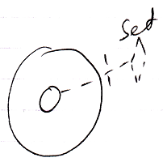
Reference Class Get | Object Class Get
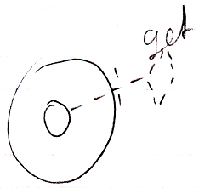 | 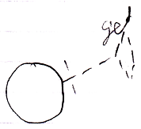
Value Get | Value Set
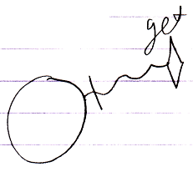 | 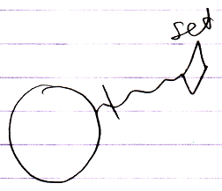
Clone (2) Get | Clone (2) Set
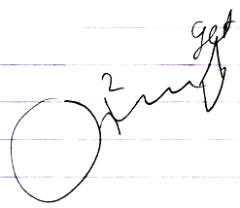 | 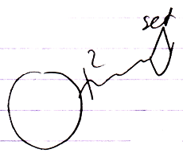
New | Annul
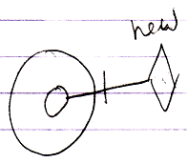 | 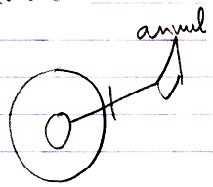
Execute
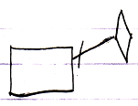
Add | Remove
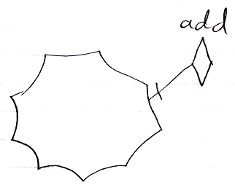 | 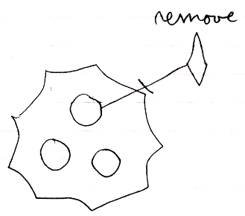

Usually a Get command or Use As command is immediately followed by a Set command.
But in the overview above you see isolated Get, Use As and Set calls. You will probably not see that happen in actual programs, but the notation above is later used in composite notations.

See also: System Objects

Author & Copyright: Jan-Joost van Zon Date: July 24, 2009 – July 24, 2009 Location: Oosterhout, The Netherlands Status: Finished

